**2. What is OOP? List OOP concepts.**

🡪 Object-oriented programming (OOP) is a programming model that uses classes and objects to create software programs. Some of the main concepts of OOP include:

* Encapsulation: Protects data in a class from outside access by hiding it from the system.
* Abstraction: Hides complexity and only shows relevant information to users.
* Inheritance: Allows a child class to inherit the fields and methods of a parent class.
* Polymorphism: Allows objects to perform a certain action in different ways.
* Association: The connection between one or more classes.

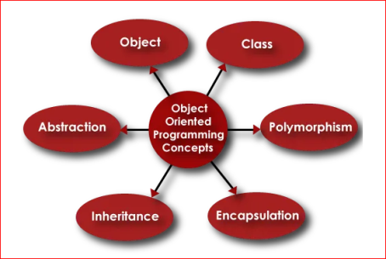

The organization of an object-oriented program also makes the method beneficial for collaborative development, where projects are divided into groups. Additional benefits of OOP include code reusability, scalability and efficiency.

**3. What is the difference between OOP and POP?**

OOP is Object-Oriented Programming, and POP is Procedure-Oriented Programming. OOP has three accessing modes: “Public”, “Private”, and “Protected,” while POP has no specific accessing modes.

* Focus: OOP focuses on data security, while POP focuses on completing tasks.
* Approach: OOP uses a bottom-up approach, while POP uses a top-down approach.
* Data hiding: OOP supports data hiding through encapsulation, while POP does not.
* Inheritance: OOP supports inheritance, while POP does not.
* Polymorphism: OOP supports polymorphism through virtual functions, while POP does not.
* Code reusability: OOP supports code reusability, while POP does not.
* Accessing modes: OOP has three accessing modes: public, private, and protected, while POP has no specific accessing modes.
* Examples: Examples of OOP include C++, Java, VB.NET, and C#.NET.

